# Real-Time Age Detection Using a Convolutional Neural Network

**Abstract**

Goal of paper is creating lightweight ML for automating the task of detecting people’s age. 🡪 To do so, they used a (modified) CNN (LeNet-5 architecture).

To train and test the model 🡪 UTK-Face dataset.

They applied the model real-time to check people’s predicted age.

**Similar work**

Fusion Network (FusionNet)

A CNN architecture like FusionNet extracts age-related facial attributes in order to emphasize features that are specific to the aging.

Optimized CNN Architecture [10]

CNN that consisted of 6 layers for age detection.

* 4 CONV layers
* 2 fully connected layers

Authors experimented with 16 different architectures, ranging from

* 2 layers CONV 🡪 5 layers
* 1 layer fully connected 🡪 4 layers

Matching Convolutional Neural Network

This neural network takes a facial image as input with a target image that is younger, similar or older than 🡪 perform also age estimation.

**Proposed work**

Usage of modified LeNet-5 CNN architecture.

**Experimental setup**

Categorial classes:

* 0: 1-10
* 1: 11-20
* 2: 21-30
* 3: 31-40
* 4: 41-50
* 5: 51-60
* 6: 61-70

**Architecture**

* Input: 200 x 200 RGB (200, 200, 3)
* 1st convolutional layer: 6 x 7 x 7 filters
* 2nd convolutional layer: 16 x 3 x 3 filters
* Both conv layers se ReLU
* 1st fully connected layer has 120 nodes
* Output layers uses SoftMax

**Training**

* 6160 samples
* Categorical Cross Entropy
* Evaluated on accuracy
* 100 epochs with mini batch of 32

**Experimental results**

* Overall accuracy is 45.3%
* Validation accuracy converged after 20 epochs
* Validation loss continuously increased

# Age Estimation System Using Deep Residual Network Classification Method

**Abstract**

* They compare Resnet with ResNeXt-50

**Introduction**

The most widely used method for estimating the age of facial images consists of two steps. They are local feature extraction and regression (or classification).

**Related work**

Age estimation

Previous work that focussed on age estimation:

* AGing PattErn Subspace
* Local Binary Patterns
* learning ordinal discriminatory features
* Recently CNN made a breakthrough.

Convolutional Neural Network

* Activation units called ReLU can help with achieving higher accuracy (with source)
* Drop out can prevent over fitting (also mentioned with source)

Deep Residual Network

* ResNet allows to train up to hundreds or even thousands of layers and still achieve interesting performance. 🡺 gradients are propagated back to the previous layer
* ResNet architecture introduces skip connection

**RESIDUAL NETWORK CLASSIFICATION FOR AGE ESTIMATION METHODOLOGY**

System Design

* Training 80%, Validation 10%, Test 10%
* Each image is normalized
* Cross-entropy loss is commonly used as a loss function
* Adam [23] is an adaptive learning rate optimization algorithm that can used instead of the classical stochastic gradient descent procedure to update network weights iterative based in training data.
* Batch of images is loaded

Evaluation Criteria

* Mean Absolute Error (MAE)

**EXPERIMENTAL RESULT**

* Learning rate are 0.001
* Training epochs are 200

For both the Resnet 50 and ReNeXt 50 (32 x 4d) the training loss and training accuracy stagnated at around 35 epochs.

**CONCLUSION**

They obtained better results with deep residual networks for the regression problem of age estimation.

# Comparative Convolutional Neural Network for Younger Face Identification (not really interesting)

**Abstract**

Focus on distinguishing two images and who is younger.

**Introduction**

Proposed method is two-stream convolutional neural network (that takes two images as input).

# Project steps

* 1. LeNet-5 CNN architecture

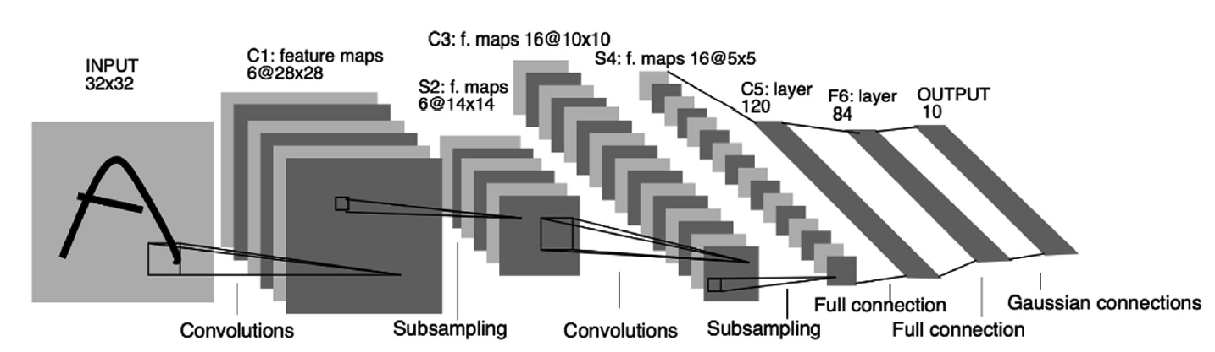

* 2. Modified LeNet-5 CNN architecture (Sithungu, Van der Haar)

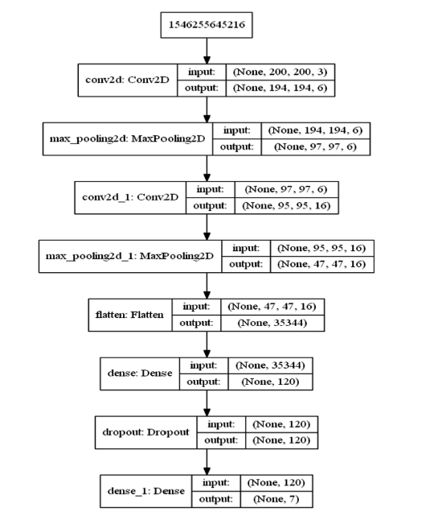

* 3. ResNet
* 4. ResNeXt
* 5. ResNeXt-50
* 6. ResNeXt-50 (32 x 4d)